Insurance Module – Functional Requirements (Rewritten)

1. Insurance Master – Core Structure
A centralized Insurance Master must be created to manage multiple types of insurance policies.
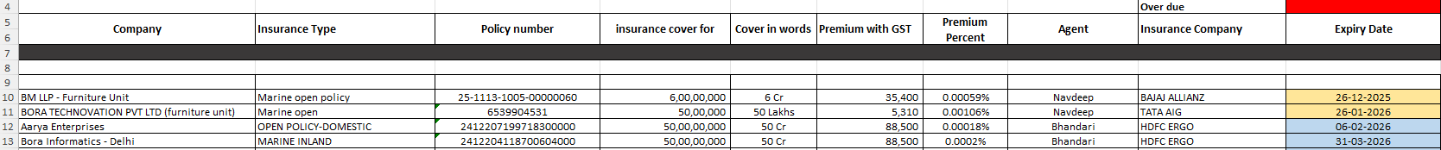
1.1 Insurance Type Configuration
- Multiple Insurance Types to be defined.
- Creation, modification, and deletion rights restricted to Admin only.
- All insurance-related forms should expose Insurance Type as a dropdown (user-selectable).
1.2 Policy Number Handling
- Policy number is generated post payment.
- Field type: Text box (manual entry).

2. Insurance Creation via Payment Entry (Top-ups & Additions)
- Initial insurance master setup will be done once.
- Any new insurance entry or top-up must be initiated from the Payment Entry screen.
When a user records an insurance-related payment, a popup form should appear with the following fields:
# | Field Name | Type / Logic
1 | Company Name | Dropdown
2 | Insurance Type | Dropdown
3 | Policy Number | Text box
4 | Insurance Cover For (Sum Insured) | Text box
5 | Cover Amount (in words) | Auto-converted
6 | Premium (Incl. GST) | Auto-fetched from invoice/payment
7 | Agent | Text box
8 | Insurance Company | Dropdown
9 | Expiry Date | Calendar picker
All submitted data should automatically reflect in the Insurance Master.
Please note that the sum insured amount should mandatorily reset immediately after expiry.

3. Policy Structure – Individual vs Floater
- Introduce Policy Type:
  - Individual
  - Floater
Floater Policy Logic
- If Floater is selected:
  - User must be able to select multiple locations of the same company covered under the same policy.

4. Insurance Categorisation
Create high-level insurance categories for reporting and control:
- Fire, Burglary, Marine, GMC, GPA, Vehicle (Zero Dep / Third Party), Personal, Office Space, HO Assets, Any other office-related insurance
- This should be configurable to the admin only.

5. Miscellaneous Insurance Reporting
- A Miscellaneous Insurance Report is required for policies not linked to:
  - Assets, Turnover, Inventory
Examples:
- GMC, GPA,
6. Insurance Declarations – Automation
6.1 Marine Insurance Declarations
- Declarations must be submitted periodically (weekly/monthly).
- Coverage based on sales value (incl. GST) for the selected period.
System Requirements:
- Configurable declaration templates.
- Auto-generated declaration values.
- Ability to email declarations directly to insurance companies. Email to be in draft stage, user sends manually.

6.2 Fire & Burglary Declarations
- Declarations based on inventory value per warehouse.
- Inventory value logic:
  - Monthly average inventory held in the warehouse for the selected period.

7. Fire & Burglary Insurance Report
A dedicated report is required for Fire and Burglary insurance.
- Report structure and column headers are self-explanatory (as per shared format).
- Data to be auto derived from insurance master and inventory records.
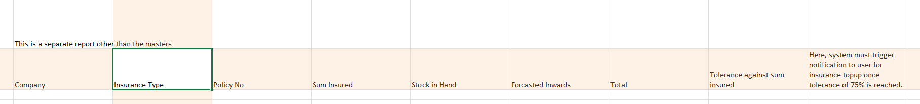

8. Marine Insurance Report
A separate report for Marine Insurance with predefined columns as per screenshot attached.
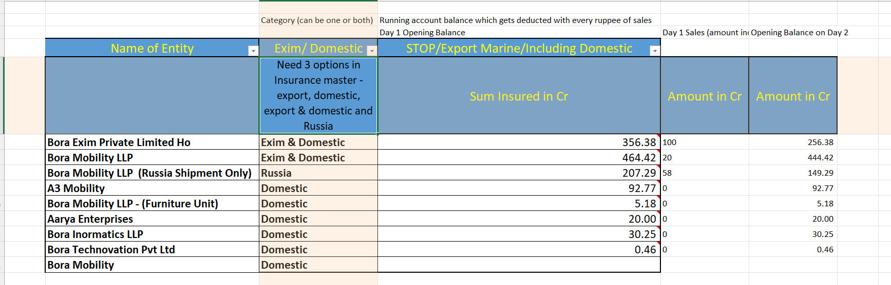
8.1 Marine Insurance Configuration
- Marine insurance applicability must be configurable at Admin level:
  - EXIM, Domestic, Both, Russia only
Users should only be able to select from these predefined options via dropdown.
8.2 Sum Insured Logic
- Sum Insured acts as an Opening Balance.
- For Marine Insurance:
  - Every rupee of revenue generated must be deducted live from the sum insured.
  - Remaining balance must update dynamically in the same column.
  - On expiry of such policy, the balance sum insured to be reset to 0 and user will add new policy.
  - Expired policies with 0 sum insured should remain in the masters but view should only display the active policies.
- The last two columns in the report are for explanatory/reference purposes only and must not affect calculations.

9. Insurance Master – Financial Tracking
The Insurance Master must maintain:
- Company, Sum Insured, Premium Paid, Percentage (premium/sum insured), Expiry Date
- Once Expiry is triggered, policy status to set as expired and new active policy to be added to master by the user. (Active/Expired status to be assigned to policies)

All insurance-related payments should automatically:
- Update the master
- Adjust balances
- Maintain audit consistency

10. Declaration Download & Bulk Generation
Users must be able to generate declaration letters with the following controls:
- Select Date From and Date To
- Auto-fetch sales amount/inventory amount for the selected period
- Select entity:
  - Bora Exim – Combined
  - Bora Exim – Delhi
  - Bora Exim – Pune
Bulk Declaration Support
- Ability to:
  - Select multiple companies
  - Download declarations in bulk in one action

